1. For what reason would retailers like The Gap select an accounting period that ends on or near the end of January?

2. Which one of the following accounts most likely would appear on the income statement of a merchandise company, but not on the income statement of a service company?

3. A customer returned damaged goods for credit. Which of the seller's accounts decreases?

4.
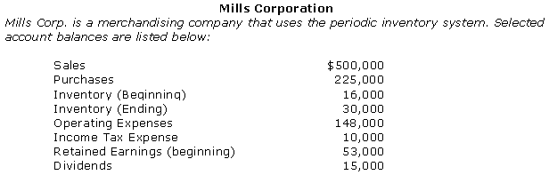
Refer to Mills Corp. Calculate the cost of goods sold for Mills Corp.

5. Refer to Mills Corp. Calculate the gross profit.

6. Refer to Mills Corp. Calculate net income.

7. What effects on a retail store's accounting equation occur when merchandise returned by customers is recorded?

8. Silvertone Corp. sold merchandise to a customer on credit. The invoice amount was $1,000; the invoice date was June 10; credit terms were 1/10, n/30. Which one of the following statements is true?

9.
Refer to Lighting, Inc. If Sporting Corp. pays the amount of the invoice for its purchase on March 14, 2010, how much cash will Lighting receive from Sporting Corp.?

10. Refer to Lighting, Inc. Sporting Corp. paid the invoice on July 31, 2010. How much sales discount will Lighting recognize?

11. Seller, Inc. sells merchandise on credit. If a customer pays its balance due within the discount period, what is the effect of the payment on Seller's accounting equation?

12. Seller, Inc. sells merchandise on credit. If a customer pays its balance due after the discount period has passed, what is the effect of the payment on Seller's accounting equation?

13. In order to determine inventory for its balance sheet, a company must count the inventory at the end of its accounting period for

14. How are purchase discounts and purchase returns recorded by a company using the periodic inventory system?

15.
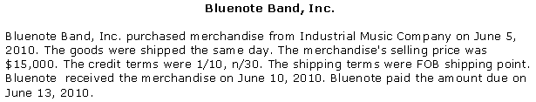
Refer to Bluenote Band, Inc. If Bluenote uses the periodic inventory system, the effect of recording the payment on June 13, 2010, will include

16. Which one of the following is not a contra account?

17. The ending inventory balance represents

18. Cost of goods sold represents

19. Which method assigns the cost of the most recent items purchased to ending inventory?

20. Which method assigns the cost of the most recent items purchased to cost of goods sold?
21. Which method assigns the same cost to all units whether sold or left in ending inventory?

22. For which type of inventory would a company most likely use the specific identification method?

23.
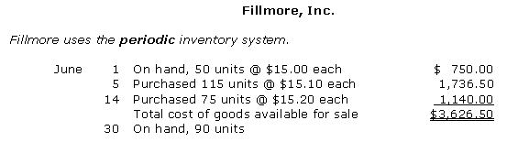
Refer to Fillmore, Inc. If the June 30th inventory included 45 units from the June 5th purchase and 45 units from the June 14th purchase, Fillmore' cost of goods sold for June under the specific identification method would be

24. Refer to Fillmore, Inc. If Fillmore uses the FIFO inventory method, the amount assigned to the June 30 inventory would be

25. Refer to Fillmore, Inc. If Fillmore uses the weighted average cost inventory method, the amount assigned to the June 30th inventory would be

26. Refer to Fillmore, Inc. If Fillmore uses the LIFO inventory method, the cost of goods sold for June would be

27. Refer to Fillmore, Inc. How many units did Fillmore, Inc. sell during June?

28.
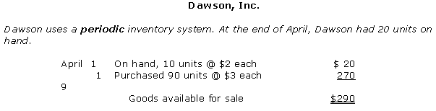
Refer to Dawson, Inc. If Dawson, Inc. uses FIFO inventory costing, how much is cost of goods sold for April?

29. Refer to Dawson, Inc. If Dawson, Inc. uses the weighted average cost inventory method, how much is cost of goods sold for April?

30. Refer to Dawson, Inc. If Dawson uses the LIFO inventory method, how much is inventory on the balance sheet as of April 30?

31. A major advantage of the weighted average method of inventory costing is that

32. Which method of inventory costing is not acceptable for financial accounting purposes?

33. Which inventory costing method results in the highest inventory balance during a period of rising prices?

34. Which one of the following statements regarding changing inventory methods is true?

35. If cost of goods sold under FIFO was $8,000 and was $10,000 under LIFO, assuming a tax rate of 40%, how much tax savings resulted from using LIFO?

36. Match the terms with the descriptions related to merchandise sales and purchases.
a. Transportation-in
b. Perpetual inventory system
c. Net purchases
d. FOB Destination
e. Cost of goods available for sale
f. Periodic inventory system
g. FOB Shipping point
h. Delivery expense
37.
Marshall Company sells auto parts. The company employs a periodic inventory system. Identify all the effects on the accounting equation.
1. | Sold merchandise on credit to customers. | _________________
2. | Recorded cash sales for the day. | _________________
3. | Gave a customer a cash refund. | _________________
4. | Collected cash from a customer for payment within the discount period. | _________________
5. | Granted a customer a credit on its balance due for goods that were returned. | _________________

38.
Match the costs that might be included as part of the cost of inventory to the listed accounting treatment.
1. | Invoice price paid for resale goods | _________________
2. | Freight costs incurred by the buyer to ship goods to its place of business | _________________
3. | Freight costs incurred by the seller to ship goods to its customers | _________________
4. | Cost of storing the goods before they are sold to customers | _________________
5. | Excise taxes paid on goods acquired | _________________
6. | Sales taxes paid on goods acquired | _________________
7. | Income taxes paid on profits earned from selling goods to customers | _________________
8. | cost of insurance during transit to acquired inventory items | _________________

